**VAISHNAVI E 231901059**

**EX. NO: 4A**

**DATE: 05.02.2025**

**EMPLOYEE AVERAGE PAY**

**AIM:**

To find out the average pay of all employees whose salary is more than 6000 and no. of days worked is more than 4.

**ALGORITHM:**

1. Create a flat file emp.dat for employees with their name, salary per day and number of days worked and save it.
2. Create an awk script emp.awk
3. For each employee record do a. If Salary is greater than 6000 and number of days worked is more than 4, then print name and salary earned b. Compute total pay of employee 4. Print the total number of employees satisfying the criteria and their average pay.

**PROGRAM CODE:**

BEGIN {

totalPay = 0; count = 0;

print "EMPLOYEES DETAILS";

}

{

salary = $2; daysWorked = $3;

totalSalary = salary * daysWorked;

if (salary > 6000 && daysWorked > 4) { print $1, totalSalary; totalPay += totalSalary; count++;

}

}

END {

print "no of employees are= " count; print "total pay= " totalPay; if (count > 0) { avgPay = totalPay / count; print "average pay= " avgPay;

**CSE-CYBER SECURITY**

**PRIYANGA M 231901037**

} else { print "average pay= 0";

}

}

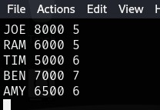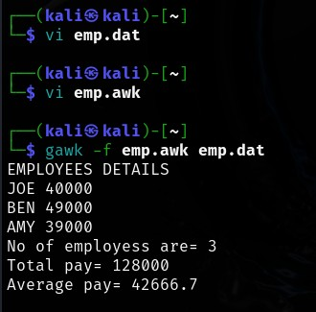

**RESULT:**

Hence, employee salary details using awk script is executed successfully.

**CSE-CYBER SECURITY**